<Moodle++>
Software Development Plan
Version <1.0>

Revision History
Date | Version | Description | Author
<29/10/2025> | <1.0> | <Software Development Plan> | <Hoàng Đôn Thiện Hòa>

Table of Contents
1. Introduction ………………………………………………………………………….. 2
2. Project Overview …………………………………………………………………….. 3
2.1 Project Purpose, Scope, and Objectives ……………………………………………………... 3
2.2 Assumptions and Constraints ………………………………………………………………... 3
2.3 Project Deliverables …………………………………………………………………………. 4
3. Project Organization ………………………………………………………………… 4
3.1 Organizational Structure …………………………………………………………………….. 4
3.2 Roles and Responsibilities …………………………………………………………………... 5
4. Management Process ………………………………………………………………... 6
4.1 Project Estimates …………………………………………………………………………….. 6
4.2 Project Plan ………………………………………………………………………………….. 7
4.2.1 Phase and Iteration Plan …………………………………………………………………… 7
4.2.2 Releases ……………………………………………………………………………………. 8
4.2.3 Project Schedule …………………………………………………………………………… 8
4.3 Project Monitoring and Control …………………………………………………... 9
4.3.1 Reporting …………………………………………………………………………………... 9
4.3.2 Risk Management (left blank) .……………………………………………………………. 9
4.3.3 Configuration Management ……………………………………………………………… 10
Software Development Plan
1. Introduction
This project endeavors to simulate a Learning Management System (LMS) analogous to Moodle (Moodle HCMUS), which is designed to furnish a platform for organizing, creating, and managing courses and activities with a significant emphasis on collaborative learning.
Our web application is primarily directed towards an educational context, suitable for both high school and university environments. Users will be able to access the application via a web-based hyperlink connected to a secure server. In addition to the core features typically provided by Moodle, our system will incorporate enhanced functionalities derived from existing educational portals and integrate an AI-powered module (e.g., chatbot, Q&A assistant). These extensions are intended to augment the system's user-friendliness, proactivity, and efficiency, particularly for both educators and students.
2. Project Overview
2.1 Project Purpose, Scope, and Objectives
The project aims to achieve the following objectives:
- Develop a functional LMS prototype: The primary goal is to create a learning management system prototype that accurately simulates the core functionalities of Moodle.
- Implement essential course management features: This involves integrating critical features for both students and teachers to manage courses effectively.
- Integrate an AI assistant: An AI assistant will be incorporated to provide interactive question-and-answer support and assist with course-related inquiries.
- Ensure security, scalability, and usability: The system will prioritize security, scalability, and overall usability to ensure a robust and user-friendly experience.
- Deploy the system with professional hosting: The system will be deployed using professional hosting services (domain and Virtual Private Server) for comprehensive testing and demonstration purposes.
2.2 Assumptions and Constraints
- The project is scheduled for a fixed duration of 10 weeks, with a team comprising 5 members.
- The cost incurred is minimal.
- All team members have been assigned weekly tasks.
2.3 Project Deliverables
- A Figma project illustrating the UI designs of the website.
- A document detailing the project and providing instructions on website usage.
- A comprehensive project plan report, including an overview, organizational structure, and group management processes.
- Weekly reports outlining planned tasks, progress, and future objectives.
- A vision document for the project, highlighting the problem, goal, and purpose.
- A fully functional, web-based LMS simulation incorporating AI-based support.
- Secure, scalable infrastructure utilizing Node.js, ReactJS x Vite, and PostgreSQL.
- Demonstration-ready deployment on a registered domain with VPS hosting.
3. Project Organization
3.1 Organizational Structure
The organizational structure of our group is as follows:
- Thiện Hòa is the project manager and the leader of our team,
- Hữu Thịnh is the project analyst,
- Mai Thùy is the UI/UX designer,
- Viết Thành and Đức Tâm are testers of the project.
Everyone will all develop and write codes.
The following diagram shows the structure of the group.
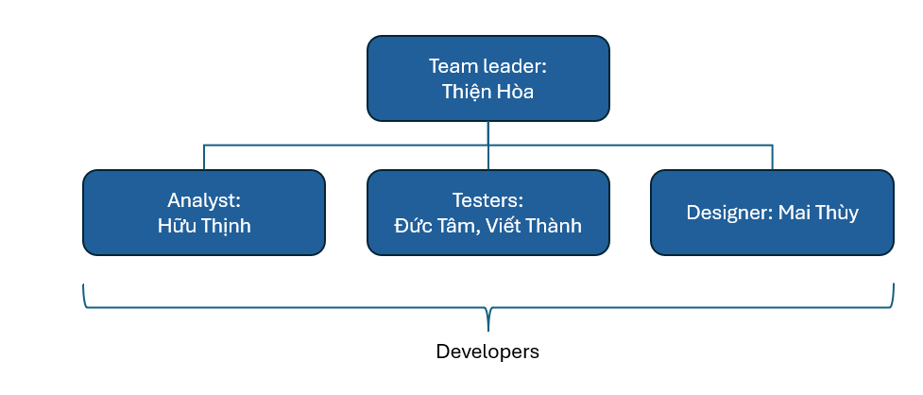
3.2 Roles and Responsibilities
Person | Roles
Hoàng Đôn Thiện Hòa | Team Leader, Developer
Trần Nguyễn Đức Tâm | Tester, Developer
Vũ Mai Thùy | Designer, Developer
Nguyễn Công Viết Thành | Developer, Tester
Nguyễn Đặng Hữu Thịnh | Project Analyst, Developer
The table below shows the roles of the members in our group.
4. Management Process
4.1 Project Estimates
- The project is planned to last for 10 weeks.
- Schedule for the project:
Phase | Duration | Estimated completion date | Basis for estimate
1. Environment Setup & Database Design | 1 week | 24/10/2025 | This is the basic setup and planning for the database.
2. UI/UX Design | 1 week | 31/10/2025 | UI design meticulously for the whole system.
3. User Interaction Module | 2 weeks | 7/11/2025 | Although the set-up-account part is not hard to implement, connecting with the database will take some time.
4. Course Management System | 2 weeks | 21/11/2025 | This requires a lot of interaction with SQL and coding.
5. Course Enrollment Module | 2 weeks | 5/12/2025 | This requires a lot of time for enrollment workflow.
6. AI Integration | 2 weeks | 19/12/2025 | This involves calling the API of the AI and making some proper adjustments.
- Project re-estimation:
Phase | Expected date | Re-estimation scope
After User Interaction Module | 14/11/2025 | Schedule review
After Completing All Features | 20/12/2025 | Full re-estimation
4.2 Project Plan
4.2.1 Phase and Iteration Plan
Phase (RUP) | Script (Scrum) | Start | End | Main objectives
Inception | 1 | 13/10 | 30/10 | - Environment set up  - Database design  - Initial requirements and plan
Elaboration | 2 | 31/10 | 01/11 | Log In & Reset Password
Elaboration | 2 | 02/11 | 09/11 | Course Interactions (Teachers):  - Upload assignments, quizzes, materials,...  - Make an announcement
Elaboration | 2 | 10/11 | 20/11 | Course Interactions (Students):  - Upload/edit/remove the homework, do the quiz…  - Announce students every time that teachers upload assignments, quizzes,...
Elaboration | 3 | 21/11 | 05/12 | Course Management:  - Admin: Add/Remove courses  - Students register courses every semester
Construction | 4 | 06/12 | 08/12 | AI Feature: Chatbot
Construction | 4 | 09/12 | 16/12 | AI Feature: Registration Control System
Construction | 5 | 17/12 | 19/12 | Finalization & Overall Testing
4.2.2 Releases
Here is the sample database of the project
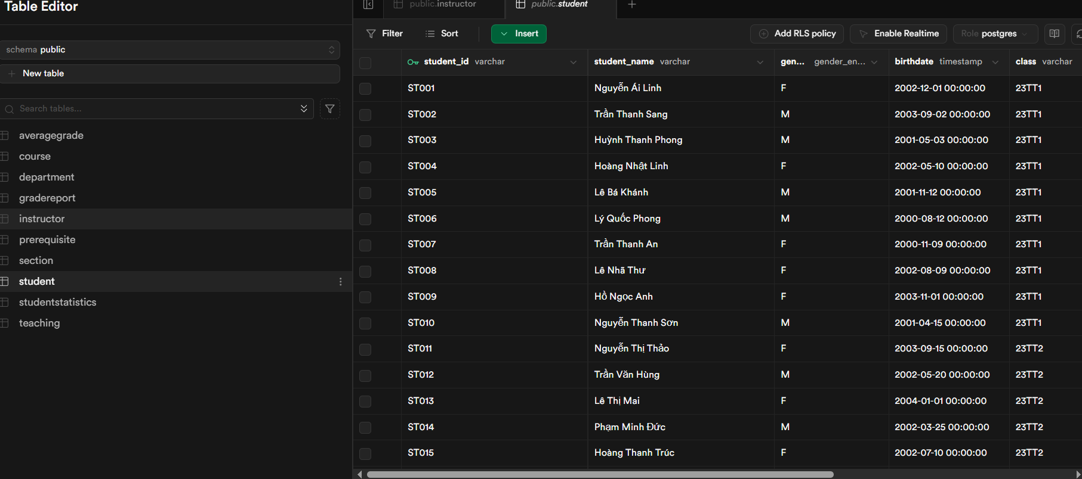
4.2.3 Project Schedule
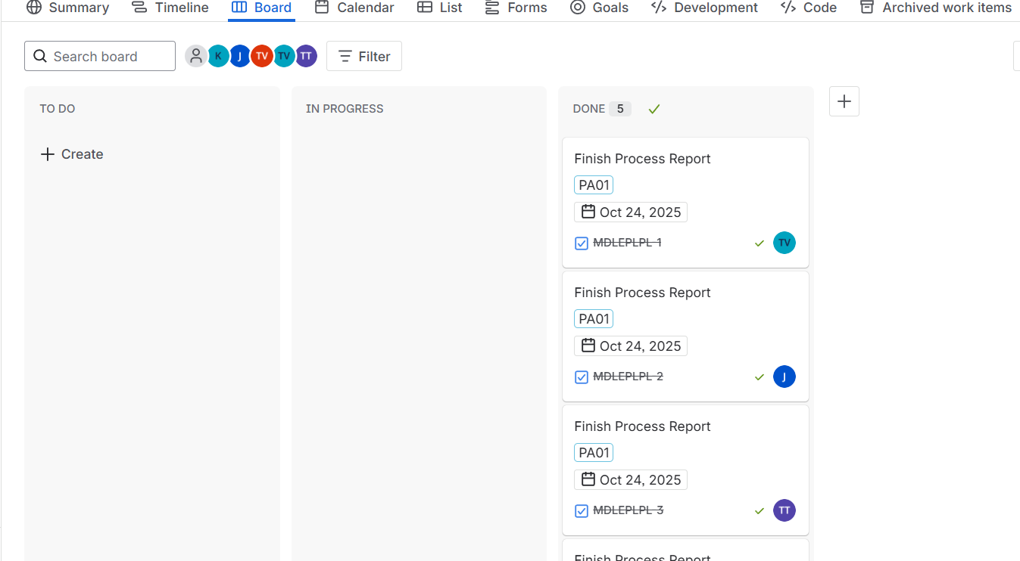
4.3 Project Monitoring and Control
4.3.1 Reporting
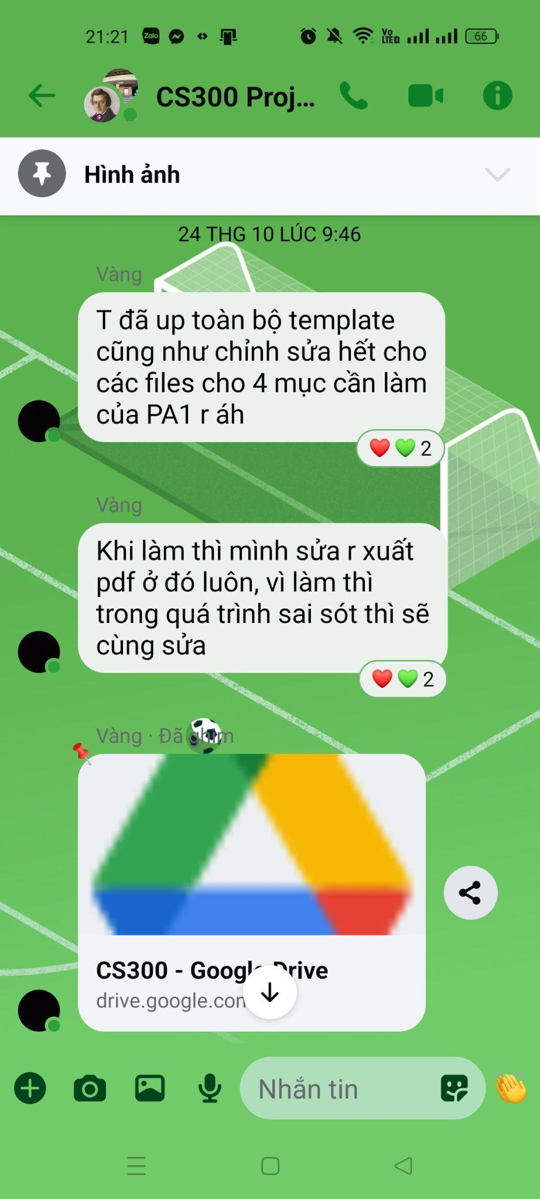
4.3.2 Risk Management (Left blank)
Risk ID | Risk Description | Probability | Impact | Risk Exposure = Probability * Impact | Priority | Mitigation Strategy or Contingency Plan
4.3.3 Configuration Management
To effectively manage this project, our team has implemented a robust version control strategy. We leverage Git, a powerful distributed version control system, for local tracking and management of all code changes. This allows individual team members to work independently, branch off for new features or bug fixes, and easily revert to previous states if necessary.
For centralized storage, collaboration, and continuous integration, we utilize Github. Through Github, we perform regular updates, push new code, and merge changes, ensuring that everyone is working with the most current version of the project. Furthermore, GitHub's features facilitate code reviews, issue tracking, and project progress monitoring, which are crucial for maintaining code quality and staying on schedule. This integrated approach of using Git for local control and GitHub for collaborative, cloud-based management ensures efficiency, transparency, and the integrity of our project's development lifecycle.

